|  |  |  |
| --- | --- | --- |
|  |  |  |

**BSc (Hons) Computing Systems**

COM188 Innovation and Society

**Design Thinking and Ideation Report**

**SOUL**

Authors

B00970291 : Farhan Bin Hossain

B00971880 : Md Azmain Iktidar Chowdhury

B00971732 : Ibrahim Sharker Maruf

B00969190 : Akir Intiser

B00971386 : Neha Rai

B00974998 : Samikshya kumal

Date: 15/03/2024

Table of Contents

Section 1: Brainwriting Snapshots 4

Brainstorming evolution 1 4

Brainstorming evolution 2 5

Section 2: Utilisation of Design Thinking and Ideation 6

Section 3: Agreed Technological Innovation and Brand Concept 7

Appendix 1: B00970291 Name: Farhan Bin Hossain 10

Brand Concept 1/3 10

Brand Concept 2/3 11

Brand Concept 3/3 12

User Persona 1/3 13

User Persona 2/3 14

User Persona 3/3 15

Appendix 2:B00971880 Name: Md Azmain Iktidar Chowdhury 16

Brand Concept 1/3 16

Brand Concept 2/3 17

Brand Concept 3/3 18

User Persona 1/3 19

User Persona 2/3 20

User Persona 3/3 21

Appendix 3: B00971732 Name: Ibrahim Sharker Maruf 22

Brand Concept 1/3 22

Brand Concept 2/3 23

Brand Concept 3/3 24

User Persona 1/3 25

User Persona 2/3 26

User Persona 3/3 27

Appendix 4: B00969190 Name: Akir Intiser 28

Brand Concept 1/3 28

Brand Concept 2/3 29

Brand Concept 3/3 30

User Persona 1/3 31

User Persona 2/3 32

User Persona 3/3 33

Appendix 5: B00971386 Name: Neha Rai 34

Brand Concept 1/3 34

Brand Concept 2/3 35

Brand Concept 3/3 36

User Persona 1/3 37

User Persona 2/3 38

User Persona 3/3 39

Appendix 6: B00974998 Name: Samikshya kumal 40

Brand Concept 1/3 40

Brand Concept 2/3 41

Brand Concept 3/3 42

User Persona 1/3 43

User Persona 2/3 44

User Persona 3/3 45

Appendix 7: Minutes of group meeting 46

# Section 1: Brainwriting Snapshots

### Brainstorming evolution 1

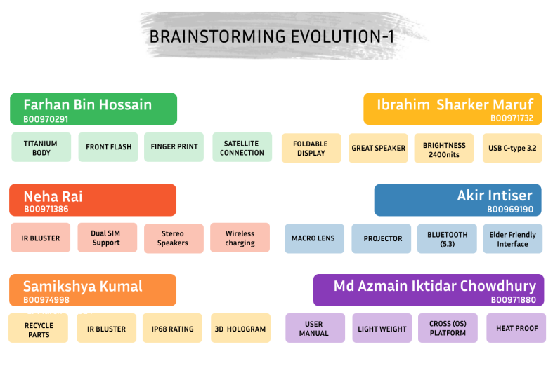

### Brainstorming evolution 2

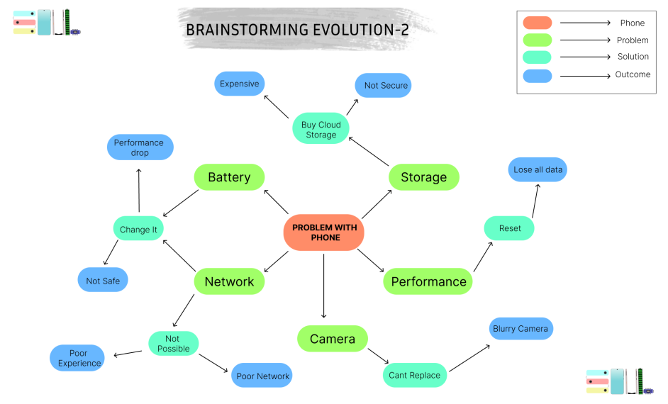

# Section 2: Utilisation of Design Thinking and Ideation

Tools has been used –

**Figma:** Figma is the best tool for creating contents like user persona, storyboard and wireframes. As it was providing us with high quality of image files and pdf's it made out project more attractive. Also, Figma is best for collaboration, as the assignment contains group works so we all had to contribute to the task, so Figma was the best choice for us. Also, Figma has a wide range of icon collection and proper tools we may need in our projects, Figma resources and fig jam has tons of template that we can use for our projects.

**Looka:** We have used Looka to make some of our logos. Looka is an ai generated website which help us to make logos. We used Looka because it was very convenient and customizable.

**Canva:** we have used Canva to make our story bords and wireframes. Canva offered several types of free photos and also it let us to generate images/sketches according to our command.

**Unsplashed:** We have used unsplashed to get free images for our user personas.

**Chat GPT:** We used ChatGPT to because it was proving us a wide range of topics and suggestions, so it help us to stick to our aim and relevant to out topic. It was time consuming to verify any information and sources in that case chat gpt was the best choice. Also our assignment must contain formal language and words so we used chat gpt to make correction on our words. It paraphrased our word and make the content more attractive. Also we took feedback from chat gpt and to proof read our content we used this tool.

# Section 3: Agreed Technological Innovation and Brand Concept

We are now in the era of modernization. When something that makes life easy, saves time and adds convenience to our day-to-day life is referred to as modern convenience. It includes mobile phones. In this ever-growing world, mobile phones are some of the popular gadgets whose upgrade happens more frequently than any other things such as more powerful chipsets, batteries, bigger displays, and huge camera sections. Therefore, phones are becoming bulky while their prices keep on increasing every day. Consequently, customers will be unable to use any phone of their choice because they fear it can break.

**SOUL**’s purpose is to serve the customer to get their desired phone which will be customizable, cheaper, and convenient. It has been designed to modify the mobile phone parts as the customer wants. Soulallows customers to pick which type of camera, processor, battery even display type. As an example, if a customer has a low budget and just wants an upgraded camera specifically but wants a low-end processor he can order online and just pay for the better camera. Therefore, he can upgrade his processor whenever he wants and can assemble on his own which will be more cost effective. Customers can also recycle the old parts and earn money which will be also better for the ecosystem. Soul is always committed to our customers to deliver updated features.

Here are some new features we have implemented in our mobile phones:

We added a foldable display for our phone to make it more futuristic as a foldable display represents the upcoming changes in the smartphone industry. The benefits of having a foldable display are so many to describe. Adding a foldable display to our phone will stand out among the other traditional smartphones in the market. Foldable screens make phones better. When it's closed, the phone is small and easy to hold with one hand. You can also use it in different ways, like folding it halfway for video calls or showing things to people. Having a foldable display in hand will also contribute a lot in the multitasking section where users can use the device in a very creative way. They can use more than one app at the same time thanks to the foldable display. Foldable displays also increase the media consumption experience by a lot. People can do their day-to-day tasks on the small display and when they want to watch a video they can use the bigger display. The foldable display will also offer a wide range of unique apps to be developed which will enhance the user experience. For this reason, adding a foldable display to our phone will increase its credibility further to the customer.

We also added dual stereo speakers which are very important for the regular usage of a mobile phone. It enhances the user experience very much when they are watching content, playing games, and listening during calls and has better environment compatibility than a mono speaker. Nowadays mobile phone companies are trending to implement normal mono speakers due to overall cost cutting sometimes using just in the higher budget phones. Soul provides high-quality speakers for all types of users even if their budget is low to make our customer's multimedia consumption more enjoyable.

Soul is always aware of the vast generation of phone users. For elder people, it often gets quite hard to understand the interface and the new terms. That’s why we added a new feature called Elder Ease. Which introduces the user manual for the mobile and then they can customize it to their choice. They can have a more specific vision of the interface, change the font sizes and there will be some video tutorials.

We have also added the latest innovation which is satellite connection with the user's mobile phone. It will help the user to connect with phone calls, send messages, access data from anywhere in the world also the network coverage. This feature will be helpful for emergency situations and can save thousands of lives. If someone feels unsafe or has some emergency conditions like being stuck somewhere or having an accident, they can access the emergency options and in one click a message will be delivered to the emergency unit and they can help him as soon as possible.

Keeping in mind that cross-platform compatibility for mobile phones allows for smooth communication and use across different operating systems such as Android, iOS and Windows among others ensures a wide range of applications and services are available to users regardless of their device’s OS thereby fostering a uniform user experience. Data synchronization features on the other hand make it easy and convenient to share contacts, calendars, emails, files etc. across multiple devices and platforms. Phones will be useable with other devices like smartwatches, and fitness trackers as well as cloud-based storage. This feature makes it convenient for users and helps developers create apps faster and cheaper. Overall, it makes the mobile experience simpler and more flexible.

We have added another new recycling feature called STOP( Sustainable Tactics for Our Planet ). The benefits of recycling features in our mobile phones are huge. To begin with, it will help to cut down costs of producing parts and as a result, make phones cheaper for customers. Second, this addresses environmental concerns by reducing electronic waste and giving components a second chance at life. This sustainability feature can appeal to a wider audience which in turn will make our phones more marketable. Also, presenting a greener face could boost our company’s image within society. Furthermore, through recycling characteristics, quick repairs are facilitated leading to more satisfied users thus enabling their basic communication requirements to be catered for accordingly.

Appendices

## Appendix 1: B00970291 Name: Farhan Bin Hossain

### Brand Concept 1/3

|  |  |
| --- | --- |
|  | This app is specifically designed for truck drivers driving on German & Swiss motorways.  It has several functions that can help a driver that needs to be on the road for a long time. It will offer fuel prices in real time to enable the lorry drivers identify the cheapest petrol stations throughout their journey. It also has an emergency call button through which Drivers could quickly reach out local police or other emergency services, or for requesting assistance from a roadside recovery service provider.  Add 'Digital driver log' feature to allow drivers monitor the hours they have spent while driving and ensure they adhere to state transport regulations. Also create reminders for truck maintenance tasks. Like changing oil based on mileage and usage of vehicle. Extend our working relationship with local traffic management authorities to provide real-time updates on road closures, road works, etc. |

### User Persona 1/3

### Brand Concept 2/3

|  |  |
| --- | --- |
|  | Fashion Craft Pro, the augmented reality device that enables users to perform their professional duties. Often, fashion designers face a number of issues when going about their assignments.  When coming up with a new idea, designers always go through a creative dilemma and have to be mindful of the current trends in the market thus this app has a ‘Trending’ section where you can get access to all modern ideas easily.  This sector depends on collaboration thus an application can be downloaded from this website which will enable managers to control their teams on it also this gadget comes with color pallets, fabrics range together with its texture as well as having VR (virtual reality) models having gesture control for user to test their new design.  Additionally, there is Ai assistant who will monitor your work and advise you according to your preference and mood. From history section the user can always access his previous works |

### User Persona 2/3

### Brand Concept 3/3

|  |  |
| --- | --- |
|  | Device Idea:  Park Guard is a application which is made for Car lovers Like John whom are struggling with their car parking. This device will monitor users reservation in parking space in front of his hosue, it will alert if any other use try to park in the reserved parking spot.  It has a feature called 'Samrt parking locator' which will help the use to find any nearby available parking space thourgh the application. It is very useful in big parking lots like shopping mall & parks. Also it will show the parking price and let then user pay for parkig through the app.  The system also has another feature named 'Parking monitoring system' with this feature user can get details of his car and get cctv footage if its available. |

### User Persona 3/3

## Appendix 2: B00971880 Name: Md Azmain Iktidar Chowdhury

### Brand Concept 1/3

|  |  |
| --- | --- |
|  | **Class Notes**  **Class Notes** is an AI based note taking web application. It offers a variety of tools which enables the personal use and organizational use better. It also a cross platform application where user can connect, save, bookmark their favourite things such as articles, videos from different social media platforms in one place. **This application main theme is learning by sharing.**  It's not only taking notes, it also offers users to turn their notes into public mode so that user can share their notes. It has range of features that helps to reduce multiple steps such as user don't need to go to calendar to set their event date or remainder whatever just using @ calendar or mention what you want to do and write down the complete task. Then Class Notes system will sync and set automatically respectively calendar apps. This platform also has a collection of note templates such as Cornell notes etc. |

### User Persona 1/3

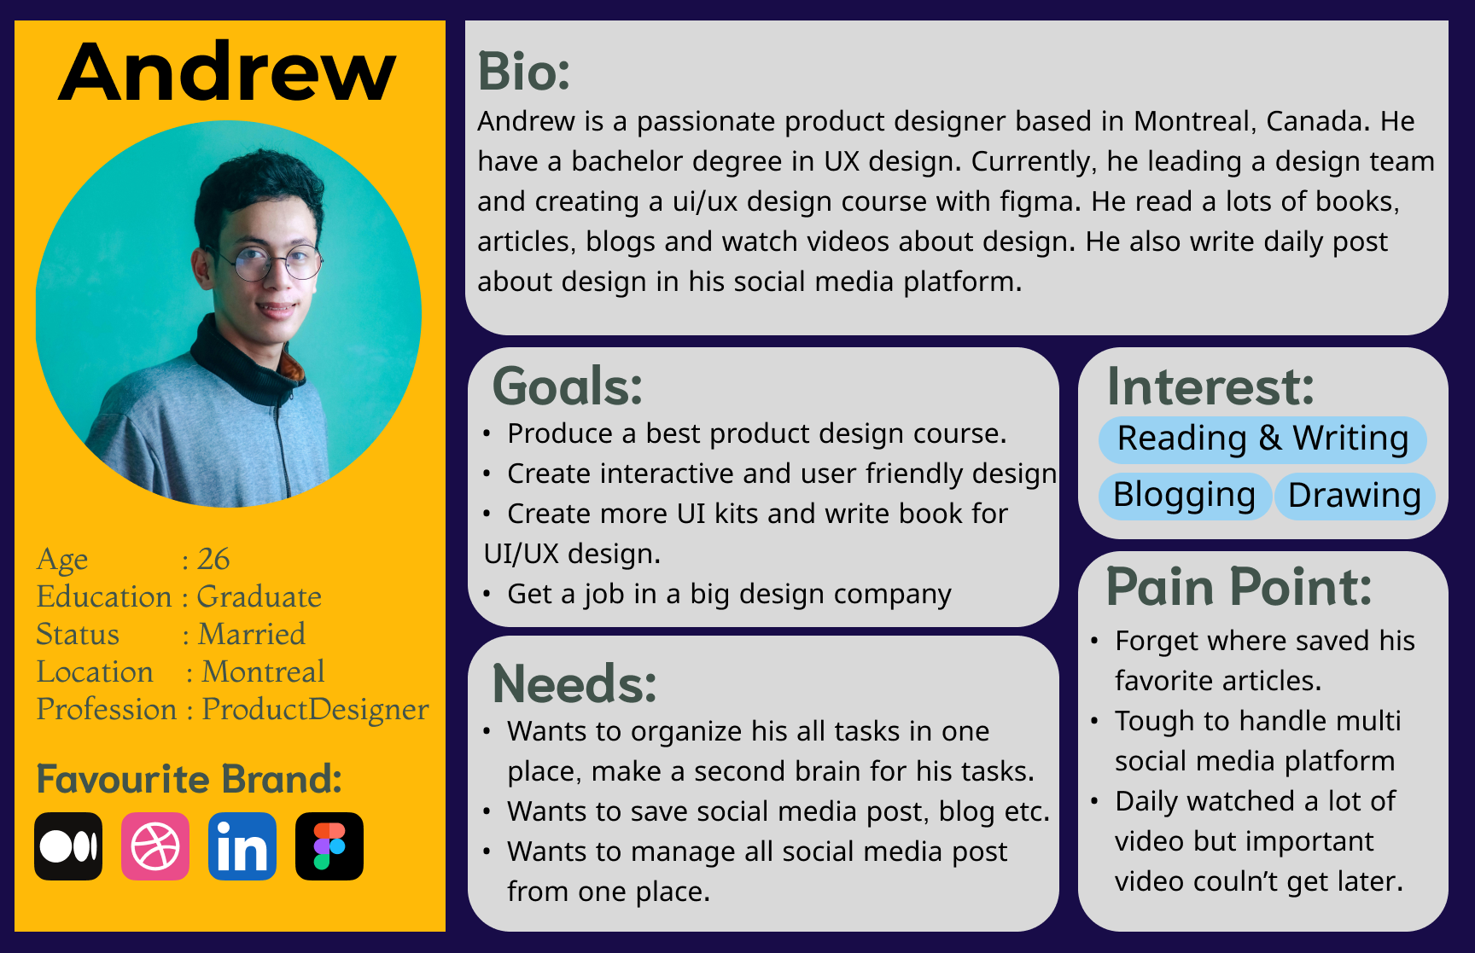

### Brand Concept 2/3

|  |  |
| --- | --- |
|  | **Uprep** is a web application platform that enables all students to get comprehensive guidelines for their higher studies through the proper guidance as well as resources. It helps to user to get update, track, and manage their application in admission time.  This application is full of resources and tools for any students. Its AI tool will be providing all university requirement, deadline, scholarship opportunity, campus details and so on by writing only few keywords. This app enables the user to access 15GB cloud storage where they keep their all-related documents in one place. This app also has ECA section where student will get daily update of ECA and Olympiad opportunity.  Uprep |

### User Persona 2/3

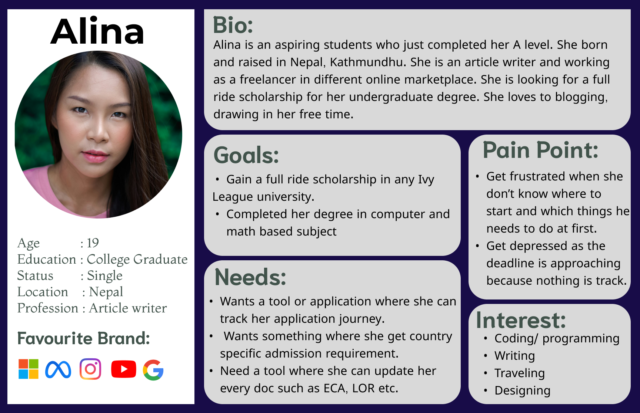

### Brand Concept 3/3

|  |  |
| --- | --- |
|  | **Test Mode** is a testing platform for any organization such as education body, trainer, business organization or personal use. This application provides a real exam environment. In this application, user such as education body can make quizzes and take test at the same platform as well as making reviews for students. If any organization or education body make the quizzes, test taker can access the exam time with QR code and teacher also see the participants numbers on the dashboard. It has AI tool which enables the user to make quizzes from their notes or lectures so that they can improve their learning by taking tests. It has also skill test such as python test, MS Excell test etc and this app will provide a certificate for the skill test.  Test Mode |

### User Persona 3/3

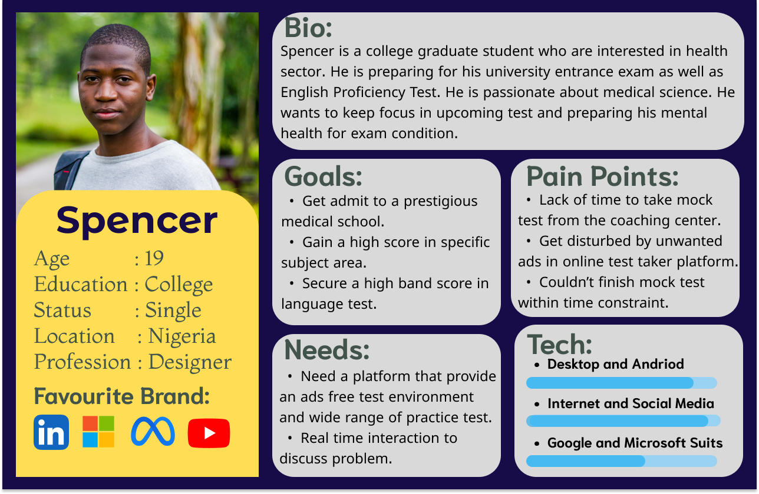

## Appendix 3: B00971732 Name: Ibrahim Sharker Maruf

### Brand Concept 1/3

|  |  |
| --- | --- |
|  | Technology such as the TechGrow makes caring for and understanding indoor plants easier. It combines cutting-edge technology with customary plant care. The apparatus can -  Soil Moisture Level Monitoring: by tracking the soil moisture the device makes sure that plants receive the right amount of water.  Soil Temperature Sensing: As the growth of a plant is affected by the temperature, so measuring the temperature will allow the user to maintain the environment of the room.  Growth Tracking: The ability to record and monitor the average growth of plants can be incredibly useful for both casual gardeners and more dedicated plant enthusiasts  Data Sharing with Scientists: The device will gather all the information about the plants and share it with the scientists. It will help a lot to study the specific plant.  Easy-to-Use Interface: The TechGrow device has its own dedicated app where users can easily monitor their plant's growth.  Extensive Plant Database: With presets for thousands of indoor plant species, the device can offer great value to the user to maintain their favourite plants.  These features can help plant lover maintain their plants efficiently and can contribute to saving the plants. |

### User Persona 1/3

### Brand Concept 2/3

|  |  |
| --- | --- |
|  | MallNav Pro is your go-to solution for finding your way in malls and supermarkets. It's like a magic map on your phone that shows you where you are and helps you find stores easily.  Some of the key features are -  - Detailed indoor maps for every floor - By making a detailed indoor map, users can find their particular chosen store very easily.  - Real-time positioning for accurate navigation: With the help of GPS users can easily find their location in a matter of seconds and move according to their comfort.  - Dynamic floor transition for seamless movement between floors - By polishing the user interface, the user can use the app without any lagging.  - Store and product locator for quick access - All the stores and products will be updated in real time so that people can easily find them.  - User-friendly interface for easy navigation - Applying all the suitable icons and perfect colour palettes to the app to give a pleasant user expression to the customers.  - Offline access for uninterrupted guidance - Sometimes in indoor situations having access to the internet might be difficult for the users, so having an option to browse the app without the internet will help the users a lot. |

### User Persona 2/3

### Brand Concept 3/3

|  |  |
| --- | --- |
|  | LineSmart makes it easier for students to use shared things like bathrooms and kitchens. This saves students time and is safe and easy to use. You can get it on your phone from the app store. It has lots of important features.  Real-time Availability Updates:  LineSmart provides instant updates on the availability of shared facilities such as bathrooms and kitchens.  Smart Queue Management System:  Students can apply for a queue over the app and save valuable time.  Occupancy Monitoring with Sensors and Cameras: The students can easily monitor the status occupancy of shared spaces. The update will be in real-time so students will not face any problems.  Privacy Protection Measures: The system is designed with privacy in mind. The collection of the data will have an end-to-end description.  User-friendly App Interface: The app will be easy to use as the main targeted customers are school students.  Customizable Notification Alerts: The students can get alerts according to their choice. Some students prefer to cook late and some prefer to cook early. So the notification alert will give them a better idea about the queue.  Continuous Improvement and Updates: The system will learn from the data that the system collects and offer better recommendations to the students for the future.  Compatibility with Various Devices and Operating Systems: The system will have its own app and can be used with iOS and Android. And we can also access the portal from the website.  LineSmart wants to make student life easier. It's there to help students whenever they need it. Making students happy is what matters most. |

### User Persona 3/3

## Appendix 4: B00969190 Name: Akir Intiser

### Brand Concept 1/3

|  |  |
| --- | --- |
|  | **Gluco Nurse**  All over the world, millions of people are suffering from high blood sugar. About four million people in the UK are now affected. The primary reasons for this problem are bad eating habits, unhealthy lifestyles, genetics and gaining weight. These habits cause not producing insulin in our blood and high blood sugar rises, which increases the risk of diabetes and related health problems. Gluco Nurse solves these issues by providing a complete answer for people in managing their blood sugar levels:  1. Sugar Level Tracking: The application provides medical information by analyzing the user's data and helps them regularly monitor their blood sugar levels.  2. Customized Suggestions: Based on the user's submission and sugar level data, Gluco Track offers recommendations for changes in diets, exercise routines, and lifestyle to help control sugar.  3. Educational Resources: Gluco Nurse app provides information about how to control blood sugar, understand diabetes, and adopt a healthy lifestyle without fearing it through articles, videos, and suggestions.  4. Paid Consultation: For users who want to hear health advice from experts, this app offers paid consultation. |

### User Persona 1/3

### Brand Concept 2/3

|  |  |
| --- | --- |
|  | We have lots of search engines that already exist. It helps a user to get his desired searches. But a lot of time users get confused because of various results, options, and product discounts. it is a big hassle when you are willing to buy any specific products online ,like mobile phones, laptops and home groceries .Without a search engine that filters results from various sources, users face difficulties such as not getting the perfect information or overload of info, irrelevant search results, limited options, and sometimes privacy concerns.  Filter Finds helps to overcome these challenges for users .it filters the results from various sources and search engines, it provides users with specified and relevant search results, reduces irrelevant information, shows more accurate and useful information, offers a comfortable search experience and assures privacy concerns. This will streamline the search process, especially for online shopping, by simplifying decision-making and upgrading user satisfaction. |

### User Persona 2/3

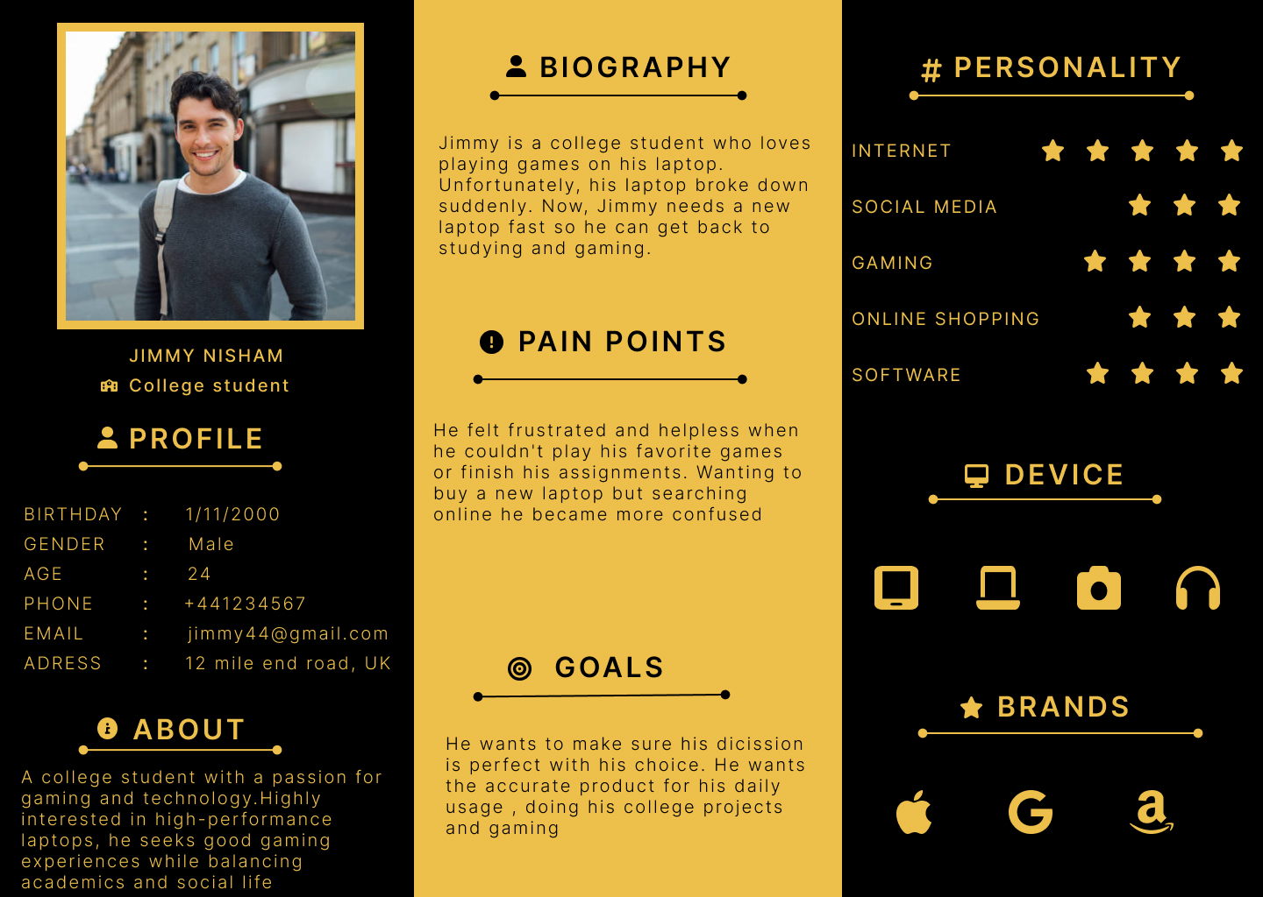

### Brand Concept 3/3

|  |  |
| --- | --- |
|  | **SOUL**  **SOUL**  **S_eamless Integration, O_mni-Connected, U_niquely Personalized & L_ifelong Companion**  1. identifying the problem: Mobile phones are now becoming an indispensable part of our day-to-day life. They help us stay in touch, play games, and even work. But there's a problem, Nowadays Phones cost a lot, and they're not built to last. After a few months, they start to slow down, and there's no way to improve them. It happens even with a high-end phone. So after using the phones few months, we have to replace them. sometimes we throw them away and it leads to generating more e-waste which is a big threat to the environment.  2. Solution: Imagine a phone where you could upgrade the camera when you want better pictures, change the battery when it starts to lose power, or upgrade your RAM/rom whenever you feel your phone is lagging. That's the idea behind sustainable phones. I have designed it to last for eternity and It is also more eco-friendly. |

### User Persona 3/3

## Appendix 5: B00971386 Name: Neha Rai

### Brand Concept 1/3

|  |  |
| --- | --- |
|  | **Enviro Quest**  ‘EnviroQuest’ is an app for becoming an environment champion. It is an app in which user can engage in different challenges related to sustainability and earn rewards and badges. This app inspires people for positive changes and helps people to adopt green practices. The main motive of this app is to inspire user to engage in environmental activities and maintain sustainable and ecofriendly habits in their daily life. It can aware people about the environmental issues and impact of people’s action on the planet. It has its different features to make it more enjoyable.  Some of those features are User profile and registration: It allows user to create their accounts. It collects interest of user related to sustainability and helps to set their sustainable goals. It will keep all the records of their works and achievement. Daily and weekly challenges: It includes challenges like turning off the unnecessary light during the daytime, going vegetarian for a day, eliminating single use of plastics for the entire day, planting trees, cleaning the public places, and managing the wastes. Reward and badges system, educational content, activity feed and partnership with other eco-friendly companies are other good features of it. This app collaborates with different ecofriendly brands for rewards and organise environmental campaigns. |

### User Persona 1/3

### Brand Concept 2/3

|  |  |
| --- | --- |
|  | **‘Mood Companion’** is an innovative app that is designed to provide mental health support and emotional well-being. This app has a special AI feature to analyse and understand the emotion, mood, behaviour, and stress. Due to pressure of work, study and other things, more people are suffering from anxiety, stress, and depression. So, this app aims to provide mental and emotional support for the people and overcome this problem. The app includes so many features. It allows user to log in their daily moods and emotion and provide a journal to write their thoughts and feelings. It has AI system that works as companion. User can have conversation with it. It can recognize the various emotion of the user according to the input given by the user a such as journal and mood logs. It analyses the emotions and generate personalized feedback and suggestion to the user. It can also detect severe distress or crisis and provide immediate access to emergency contacts, crisis hotline and resources. It contains various articles, videos, book, and audio related to mental health and other things that will help to reduce stress. It also includes meditation session, breathing exercises and recommend activities, exercises and resources based on user’s preferences. It provides a platform where user can share experiences and provide support to each other.t has a powerful data protection policy to ensure the privacy of user experiences. |

### User Persona 2/3

### Brand Concept 3/3

|  |  |
| --- | --- |
|  | ‘sKILLZ’ is an app that allows individuals to show all their qualifications and skills for other and potentially hire them in need according to their skills. It is a great platform for all the skilled human resources. It is also a great place for freelancer to promote themselves among the people. It Consists of different feature which will ease the individual to showcase their profiles as well as the clients to survey the profiles of the person. Users can create detailed profiles including their qualifications, skills, work experiences and education. This also allow user to upload their portfolio showing their certificate, awards, previous work, project, and other examples. This also allows the user to promote themselves in their respective field. This app includes a strong search and filtering system so that the clients can find specific skills and qualifications. It allows user to send messages, create a meeting within the app for direct communication to ease the services. It also has feature of posting different job opportunities and project for other to apply in it. This app implements strong measures to ensure the data protection and safety and has a clear term of service and user agreement. It also has a feature of showing the availability and schedules as well as book an appointment. Users are also allowed to give rating and feedback to review the services and a built a reliable reputed service. |

### User Persona 3/3

**Appendix 6: B00974998 Name: Samikshya kumal**

### Brand Concept 1/3

|  |  |
| --- | --- |
|  | The sole purpose of the application **QUICK** is to emphasize the importance of promptly reporting crimes. Reporting crime quickly is essential for protecting public safety, preserving evidence, apprehending suspects, preventing repeat offenses, supporting victims, and fulfilling legal obligations. The application will cater to users of all ages, allowing them to easily report incidents by simply opening the app. Instead of written posts, users can submit their reports through videos, which serve as straightforward and compelling evidence of the news or crime. People can easily share their experiences as sharing experiences enables quick notification to the public, creating substantial support for victims. |

Appendix 6: B00974998 Name: Samikshya kumal

### User Persona 1/3

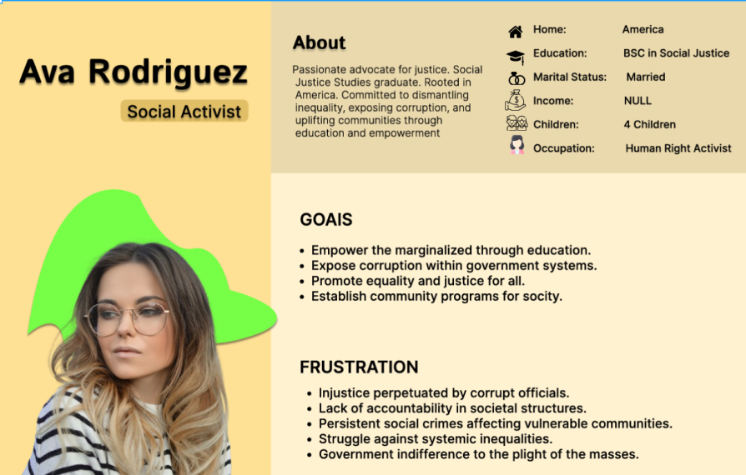

### Appendix 6: B00974998 Name: Samikshya kumal

### Brand Concept 2/3

|  |  |
| --- | --- |
|  | **Strikes Connect**  **Strikes Connect** is an application designed to facilitate peaceful strikes and enable groups to communicate their demands to the government and developed to empower individuals and communities to organize peaceful strikes, protests, and environmental causes. The app provides resources to ensure the safety and well-being of participants, including guidelines for peaceful protest behavior, emergency contact information, legal rights, and procedures. Users can create events for strikes, protests, or, rallies by providing details such as date, time, location, and purpose. Organizers can send event reminders, updates on meeting points, and safety instructions to attendees and also can offer support within event-specific chat groups. |

### Appendix 6: B00974998 Name: Samikshya kumal

### User Persona 2/3

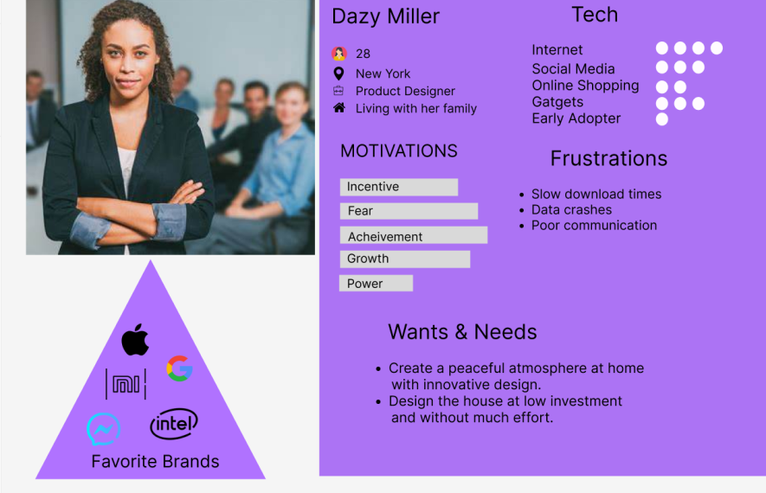

### Appendix 6: B00974998 Name: Samikshya kumal

### Brand Concept 3/3

|  |  |
| --- | --- |
|  | **Crash** is an application designed to detect and report accidents to nearby police stations and hospitals. The device is equipped with various sensors and communication technologies to detect signs of an accident and immediately notify the relevant authorities.  Here’s how such an application might work  The application utilizes sensors in the user's smartphone to detect sudden changes indicative of an accident. When detected, it automatically sends emergency alerts to nearby authorities, including precise location and relevant data. This allows for swift response and assistance from police and hospitals, aiding in efficient accident management and potentially saving lives.  **Crash** |

### Appendix 6: B00974998 Name: Samikshya kumal

### User Persona 3/3

## Appendix 6: Minutes of group meeting

**GROUP MEETING – 01**

**DATE: 19/02/2024 MEETING TIME – 34 minutes**

|  |  |
| --- | --- |
| **Member Name** | **Task Completed** |
| Farhan Bin Hossain | Finalize 1 brand idea and working on other ideas. |
| Md Azmain Iktidar Chowdhury | Finalize 3 brand ideas and working on further. |
| Ibrahim Sharker Maruf | Finalize 2 brand ideas and working on other ideas. |
| Akir Intiser | Finalize 3 brand ideas and working on further. |
| Neha Rai | Finalize 2 brand ideas and working on other ideas. |
| Samikshya kumal | Finalize 1 brand idea and working on other ideas. |
| **Final Group Review** | Everyone submitted their completed idea.  All group members were present during the meeting. |
| **Final Group Decision** | Everyone will submit their individual completed task and overview of their progress by 21st February. |

**GROUP MEETING – 02**

**DATE: 21/02/2024 MEETING TIME – 28 minutes**

|  |  |
| --- | --- |
| **Member Name** | **Task Completed** |
| Farhan Bin Hossain | Completed all of individual task. |
| Md Azmain Iktidar Chowdhury | Completed 2 User Storyboard and 2 User Persona. |
| Ibrahim Sharker Maruf | Completed 2 User Storyboard and 2 User Persona. |
| Akir Intiser | Completed all of individual task. |
| Neha Rai | Completed 2 User Storyboard and 3 User Persona. |
| Samikshya kumal | Completed 1 User Storyboard and 2 User Persona. |
| **Final Group Review** | Everyone submitted their completed task to add on final report.  All group members were present during the meeting. |
| **Final Group Decision** | AKIRS "SOUL” will be the final group idea and everyone have to be completed their rest of the task. |

**GROUP MEETING – 03**

**DATE: 26/02/2024 MEETING TIME – 72 minutes**

|  |  |
| --- | --- |
| **Final Group Review** | 1. Brainstorm Evolution has been completed. 2. Utilisation of Design Thinking and Ideation concept has been completed. 3. Agreed Technological Innovation and Brand Concept has been completed |
| **Final Group Decision** | 1. All group members were present during the meeting. 2. Make review all the group and individual task and make correction if needed. |

**GROUP MEETING – 04**

**DATE: 10/03/2024 MEETING TIME – 58 minutes**

|  |  |
| --- | --- |
| **Final Group Review** | 1. Someone has to insert everything in the template. 2. User Persona of the main idea should be changed. 3. Section – 3 needs to be elaborated. |
| **Final Group Decision** | 1. Azmain will insert individual task in the main template. 2. Akir, Neha, Samikshay and Ibrahim will make the section 3 (Agreed Technological Innovation and Brand Concept) 3. Farhan will make the User Persona and Story Board for the main concept. |